**Screen shots of output of Setting Up Jenkins Pipeline to Deploy Docker Swarm:-**

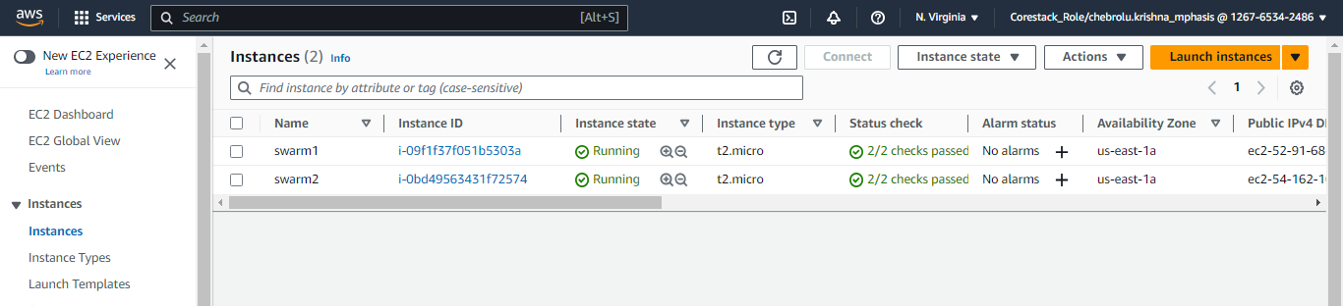

Starting manager in first instance

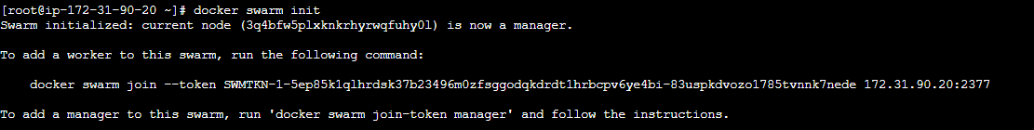

Starting worker in second instance



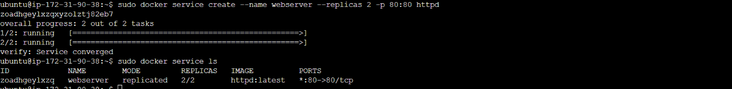



Setting up docker swarm in Jenkins pipeline

